**KAFKA TUTORIAL**

1. **Change the KAFKA_ADVERTISED_HOST_NAME in the docker-compose.yaml and create a blank .env file in geostream folder**

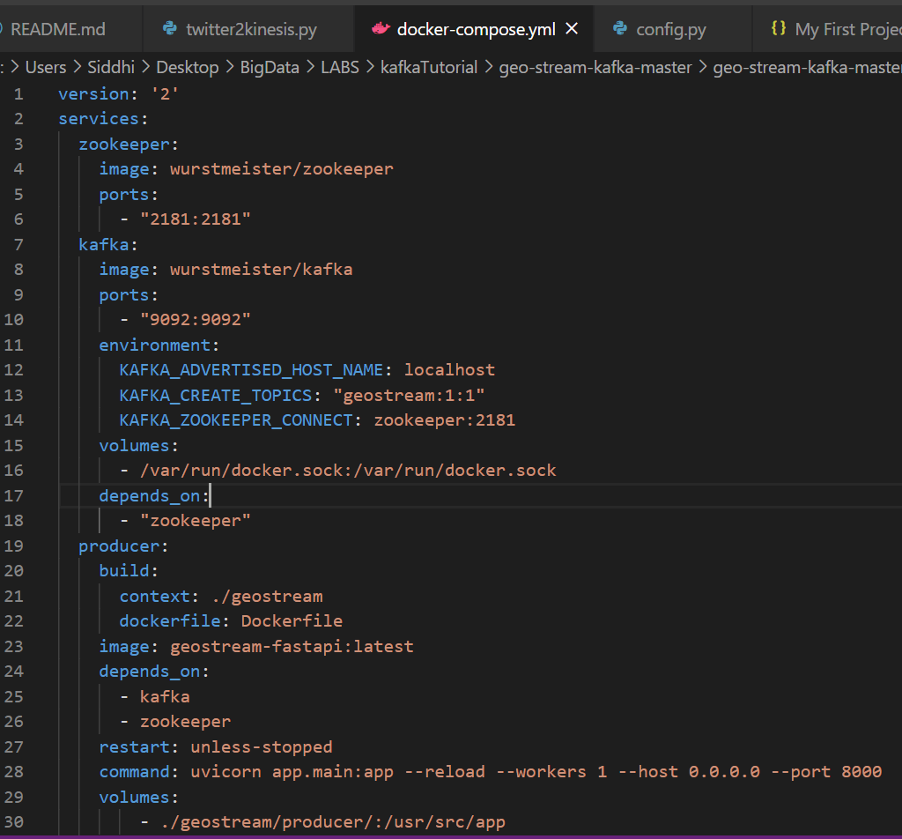

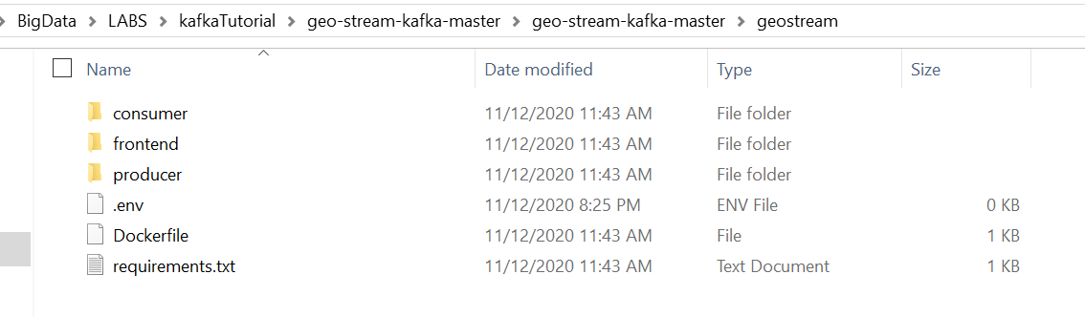

1. **Run docker and use cmd to run the following command**

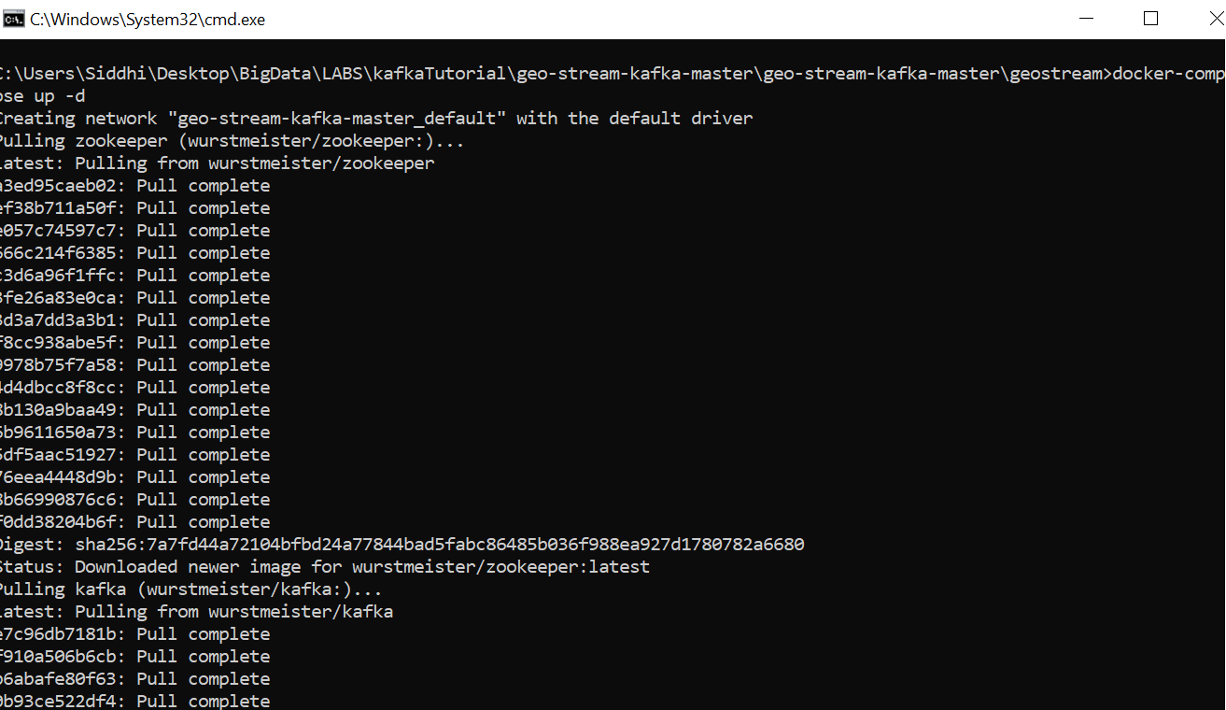

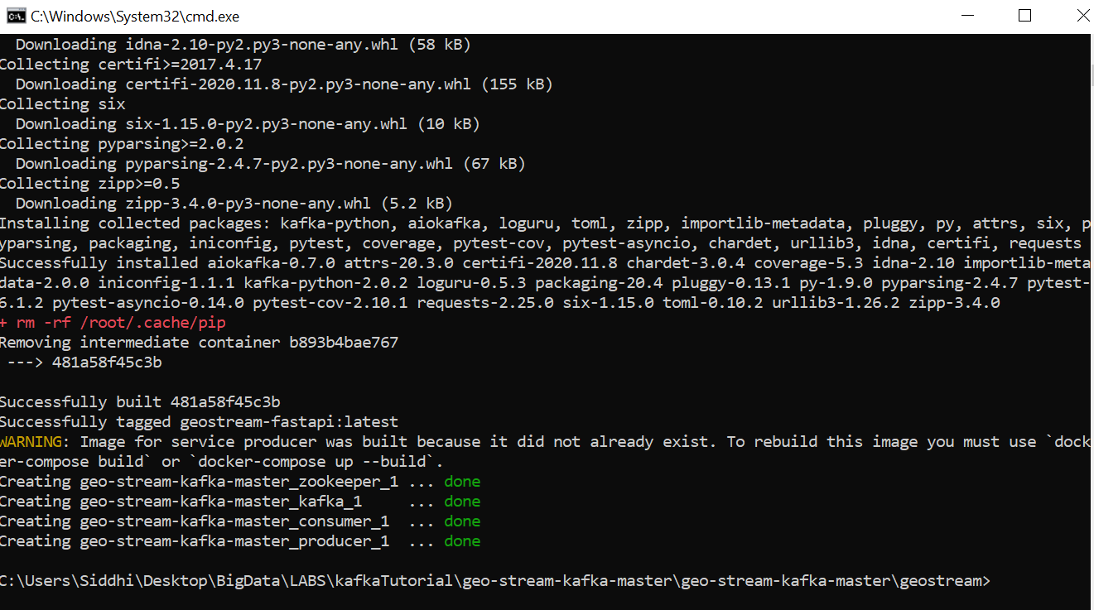

**Docker dashboard has the containers running**

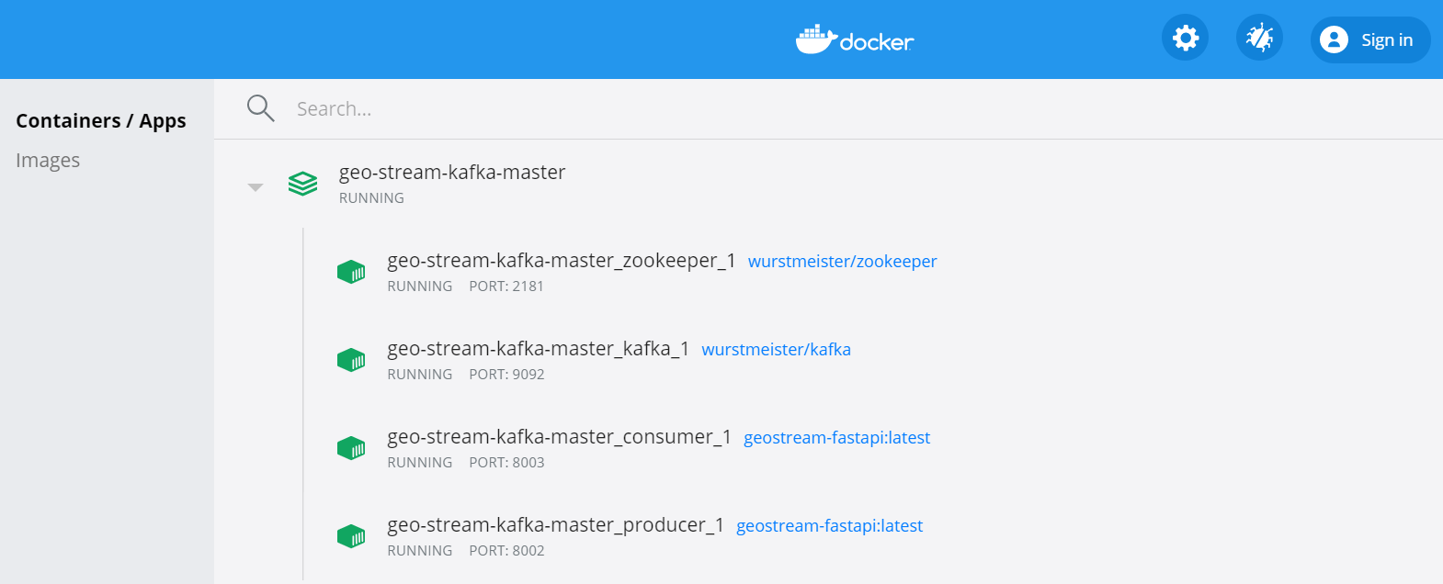

**Change the configurations of producer and consumer**

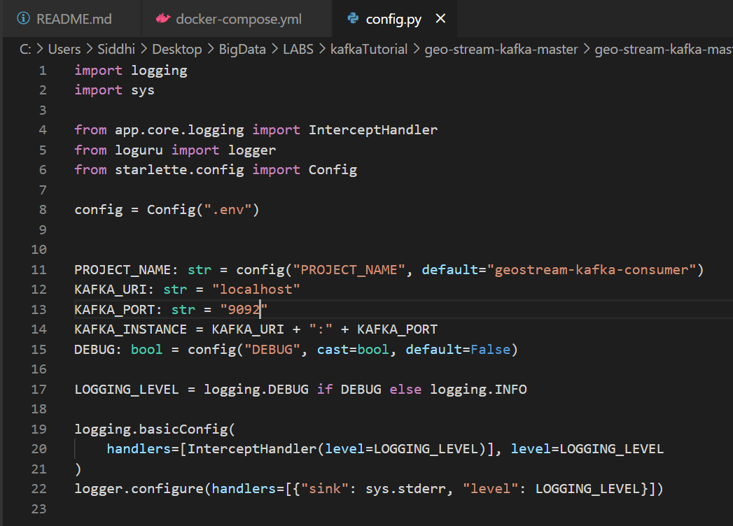

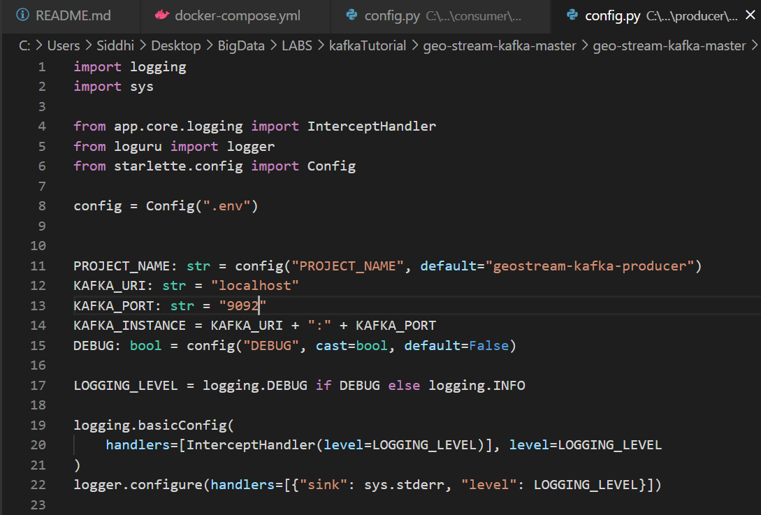

**The producer should be sending messages for the consumer to receive messages hence both should be active when trying to test**

**Producer**

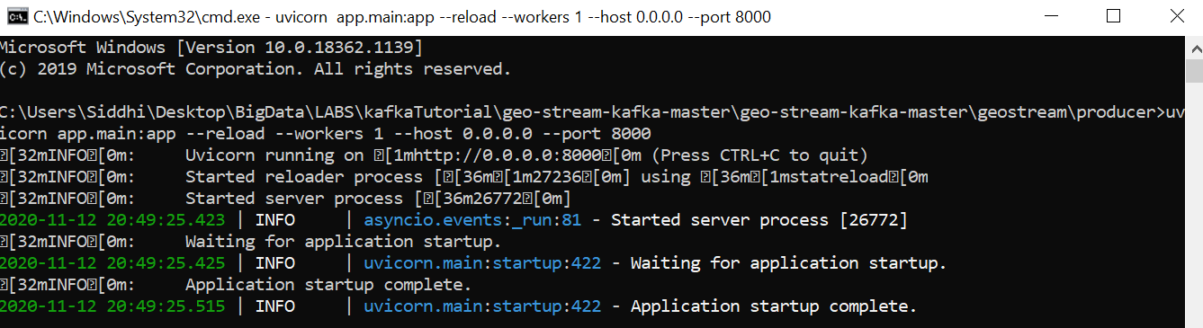

**Consumer**

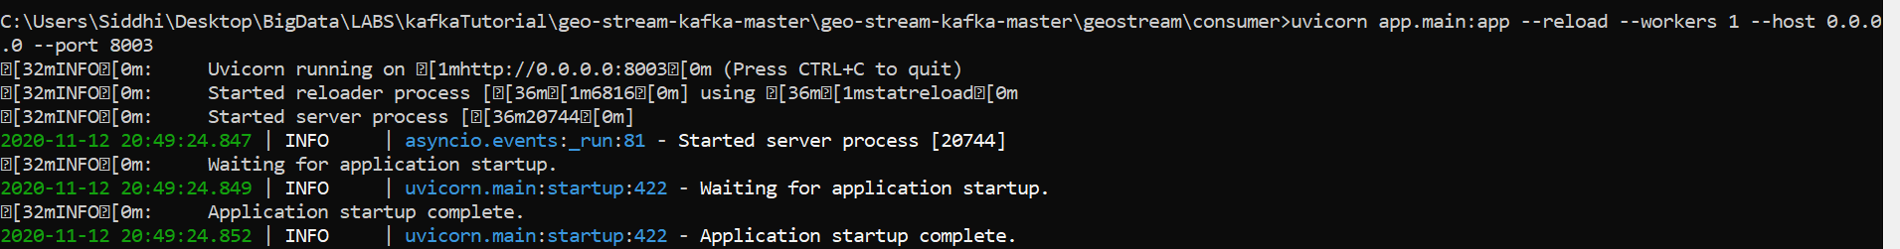

**Access the static webpage for consumer to be ready to receive the messages from the incoming websocket messages**

**After opening index.html page**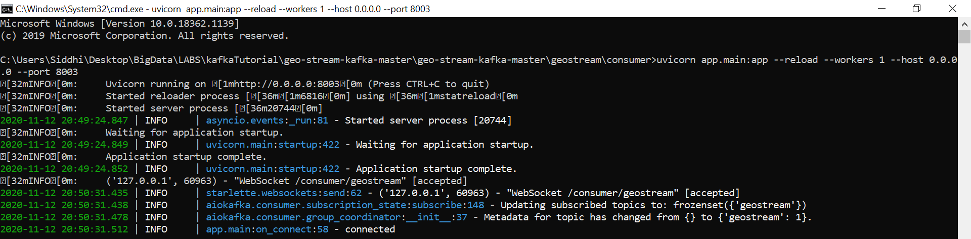

**Successfully connected static webpage**

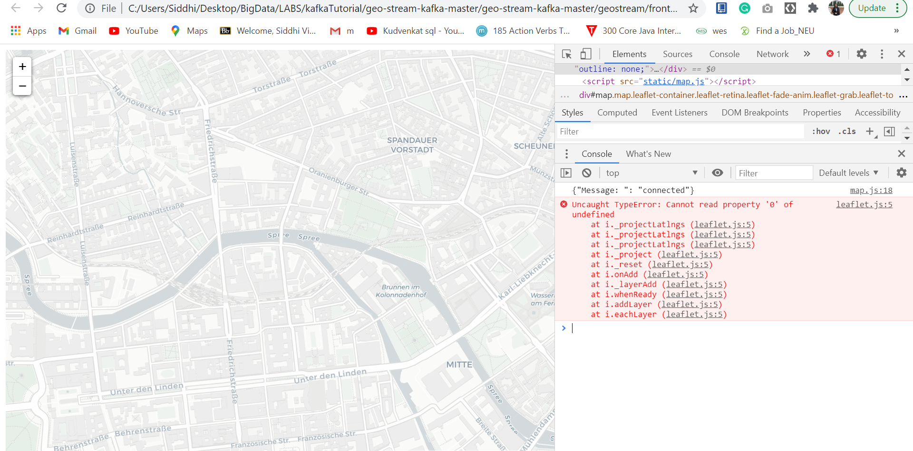

**Configure test.py file to stream data from producer to consumer**

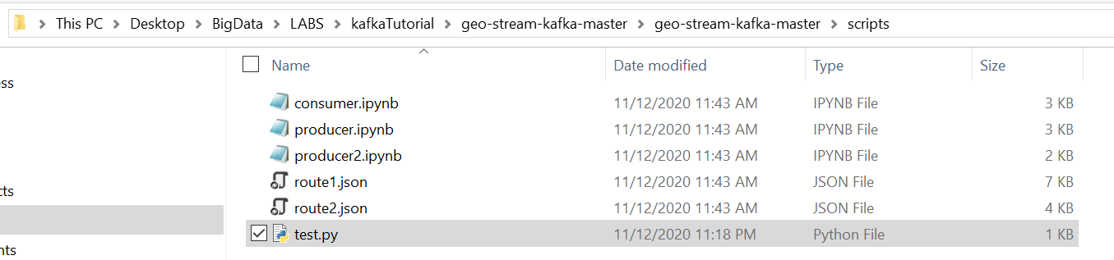

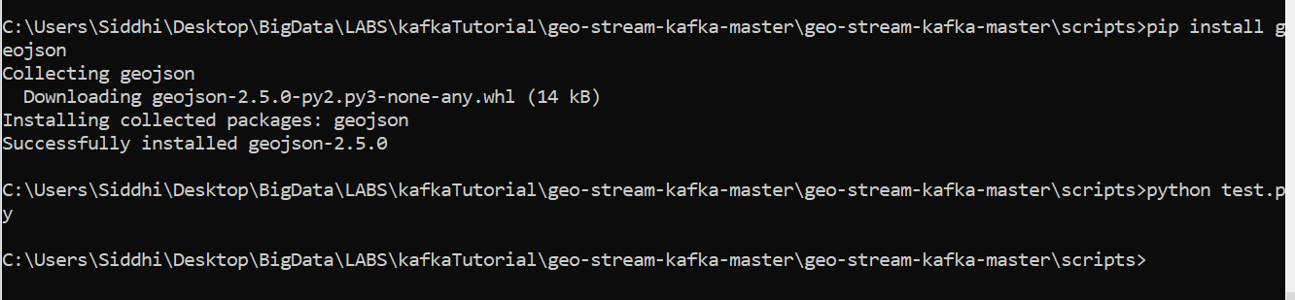

**Producer producing messages after executing python script on producer’s port**

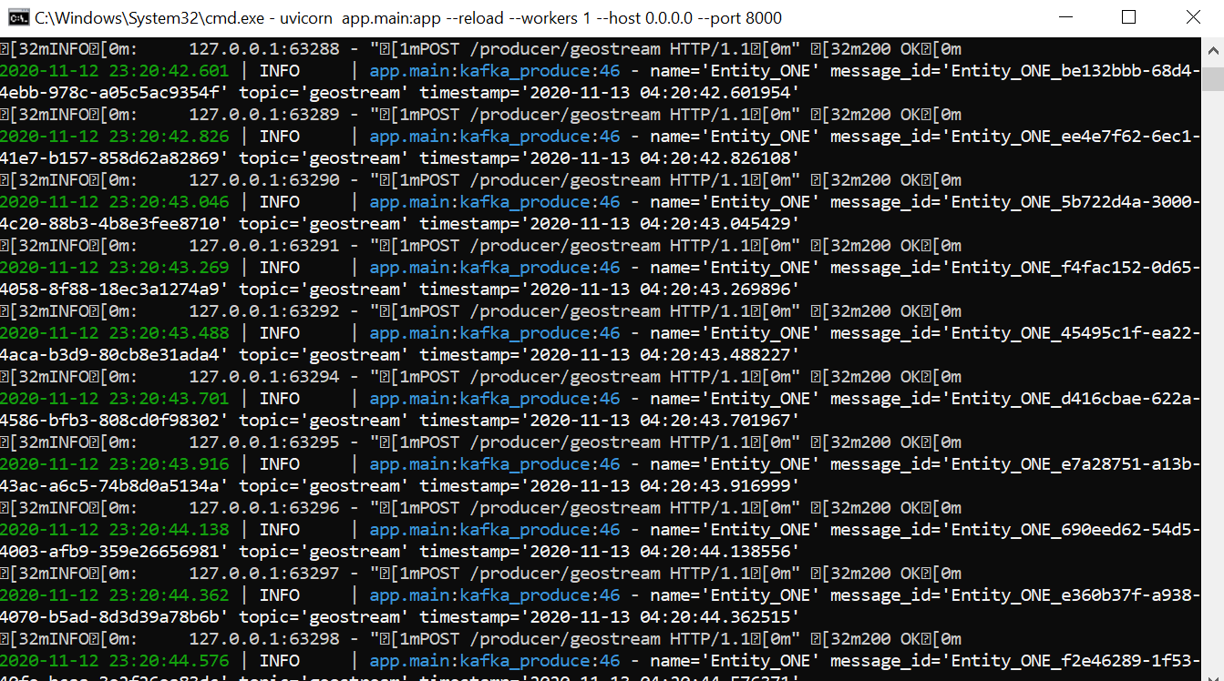

**Consumer is consuming messages**

